**Amazon Sales and Consumer Behaviour: An Integrated Approach to Market Analysis**

**Project submitted to the**

**APSSDC**

**Bachelor of Technology**

**In**

**Computer Science and Engineering**

**School of Engineering and Sciences**

**Submitted By**



**Under the guidance of**

**K. Veera Vanitha**

**K. Narmada Mani**

**Table of Contents**

|  |  |
| --- | --- |
| 1. **Abstract** 3-4 | |
| 1. **Introduction** 5-6 | |
| 1. **System Requirements**  7 3.1 Operating System Requirements  7 3.2 Software Requirements 7 3.3 Hardware Requirements 8-9 | |
| 1. **Architecture of the Project** 10 4.1 Data Ingestion Layer 10 4.2 Data Cleaning & Transformation Module 10 4.3 Feature Engineering Layer 11 4.4 Exploratory Data Analysis (EDA) Layer 11 4.5 Visualization & Dashboard Layer 12 4.6 Insight Generation & Reporting Layer 12 | |
| 1. **Uses of Data Analysis Libraries** 13 5.1 Pandas – Structured Data Manipulation 13 5.2 NumPy – Numerical Computing 13 5.3 Matplotlib – Foundational Visualization 14 5.4 Seaborn – Statistical Visualization Toolkit 14 5.5 Plotly – Interactive Visualization Framework 15 5.6 Scikit-learn – Machine Learning Toolkit 16 | |
| 1. **Project Code** 17-20 | |
| 1. **Screenshots** 20-27 | |
| 1. **Advantages** 28 8.1 Enhanced Decision‑Making 28 8.2 Operational Efficiency  28 8.3 Customer Segmentation & Profiling 29 8.4 Predictive Trend & Seasonal Analysis 29 8.5 Profitability Optimization 29 8.6 Time Efficiency & Workforce Productivity 30 8.7 Scalability & Future‑Readiness 30 8.8 Competitive Advantage 30-31 | |
| 1. **Conclusion 32-33** |
| 1. **Referencesv 34** |

**1.**  **Abstract**

In the rapidly evolving landscape of digital commerce, data-driven decision-making is a critical enabler of strategic agility, competitive advantage, and operational efficiency. This project undertakes a comprehensive analytical investigation of Amazon’s sales data, leveraging advanced data science methodologies and Python-based data manipulation ecosystems such as Pandas, NumPy, Matplotlib, Seaborn, and Scikit-learn to extract meaningful insights from voluminous datasets.

The study emphasizes a structured data analysis pipeline, commencing with data acquisition, followed by data preprocessing, including null-value imputation, data normalization, outlier treatment, and feature engineering. Rigorous data cleansing procedures are applied to mitigate data noise, reduce inconsistencies, and ensure data integrity. These steps are critical for enhancing data quality and enabling robust downstream analysis.

Through exploratory data analysis (EDA), the project uncovers latent patterns, correlations, and distributional properties within the dataset. Visual analytics, powered by insightful bar plots, line charts, heatmaps, and histograms, facilitate the intuitive interpretation of key performance indicators (KPIs) and multi-dimensional data structures. The analysis focuses on identifying seasonal demand patterns, top-selling product categories, price elasticity effects, regional sales distributions, and consumer purchase behaviours.

Further, the study integrates statistical inference techniques, including hypothesis testing, correlation analysis, and trend estimation, to validate the significance of observed phenomena and support data-backed strategic recommendations. By employing pattern recognition algorithms, the analysis identifies customer behaviour archetypes and product affinity clusters, which can inform personalized marketing strategies and inventory optimization.

The project culminates in actionable insights that can directly impact sales forecasting, market segmentation, customer retention, and revenue maximization. In doing so, it highlights the transformative role of predictive analytics, business intelligence (BI), and data visualization in modern e-commerce ecosystems. This research serves as a blueprint for leveraging sales data as a strategic asset to drive innovation, efficiency, and sustained growth in a highly competitive digital marketplace.

**2.**  **Introduction**

In the digital age, e-commerce ecosystems like Amazon generate multimodal and high-velocity datasets on a daily basis, encapsulating vast dimensions of information such as transactional records, customer behavior logs, supply chain metadata, clickstream analytics, and product-level attributes. This big data environment offers a fertile ground for extracting actionable insights that can drive strategic interventions, operational optimization, and customer experience enhancement.

The primary objective of this project is to execute a comprehensive data-driven analytical framework centered on Amazon's sales dataset, utilizing state-of-the-art data science technologies and Python-based analytical libraries such as Pandas for structured data manipulation, NumPy for numerical operations, Matplotlib and Seaborn for dynamic visualization, and Scikit-learn for foundational pattern analysis. The overarching goal is to transform raw, unstructured, and high-dimensional data into an interpretable and insightful narrative that aligns with key business objectives.

This analytical journey begins with data wrangling techniques, including data cleansing, deduplication, null value imputation, data type casting, and feature normalization, all of which are critical for ensuring data consistency, accuracy, and integrity. Following this, the project employs exploratory data analysis (EDA) to visualize core metrics such as sales volume trends, geographical sales distribution, category-wise performance, customer segmentation, and purchase frequency.

Key performance indicators (KPIs) are visualized using interactive dashboards, multi-variable scatter plots, correlation matrices, and temporal trend lines, enabling a multidimensional understanding of factors influencing product popularity, revenue generation, and customer lifecycle value (CLV). These visual and statistical techniques empower stakeholders to identify seasonal buying patterns, price sensitivity, and region-specific product affinity, which are essential for targeted marketing, inventory control, and demand forecasting.

Furthermore, the project emphasizes real-time data visualization and automated reporting pipelines, establishing a foundation for decision support systems (DSS). It advocates for the integration of predictive analytics, machine learning models, and recommender systems in future iterations. These would enable the automated prediction of high-demand SKUs, churn probabilities, and cross-sell opportunities, thereby facilitating algorithmic marketing and intelligent inventory management.

By providing a quantified evidence base and highlighting predictive market trends, this project enables Amazon and similar e-commerce platforms to enhance customer retention, optimize logistical operations, and gain a competitive edge through data-centric decision-making.

**3.**  **System Requirements**

To ensure seamless execution, efficient processing, and optimal performance of the data analysis pipeline, the system must meet the following hardware and software prerequisites. These specifications support high-throughput data manipulation, memory-intensive computations, and interactive visualization workflows.

**3.1 Operating System Requirements**

A modern, stable, and 64-bit operating system is essential to support advanced Python environments, libraries, and data science toolchains. Supported platforms include:

* Windows 10 (64-bit) or later with latest service packs and updates
* macOS Monterey (v12.0+) with developer tools installed
* Ubuntu Linux 20.04 LTS or higher for a robust open-source environment with package manager support (apt, pip, conda)

**3.2 Software Requirements**

A comprehensive Python-based ecosystem is required for executing the data analysis workflow, including data ingestion, preprocessing, visualization, and inference. Key software components include:

* Python 3.8+: Core programming environment, supporting data analysis and scientific computing libraries.
* IDE/Notebooks:
  + Jupyter Notebook: For interactive data exploration and documentation.
  + Visual Studio Code / PyCharm: For script-based development, version control, and plugin integration.
* Essential Python Libraries:
  + Pandas: For high-performance data manipulation and DataFrame operations.
  + NumPy: For optimized numerical computations and linear algebra support.
  + Matplotlib & Seaborn: For static and statistical data visualization.
  + Plotly: For advanced interactive and dynamic dashboards.
  + Scikit-learn: For implementing basic machine learning algorithms and data preprocessing utilities.
* Anaconda Distribution (optional):
  + Facilitates environment management and package dependencies via conda.
  + Offers built-in Jupyter, Spyder, and key pre-installed libraries.

**3.3 Hardware Requirements**

To process moderate-to-large datasets efficiently, and to perform high-resolution visualization rendering and basic ML model training, the following hardware specifications are recommended:

* Memory (RAM):
  + Minimum: 8 GB (suitable for basic analytics, small datasets)
  + Recommended: 16 GB or more (for large dataset handling, parallel computation, and smooth IDE performance)
* Processor (CPU):
  + Intel Core i5/i7 (10th Gen or newer) or AMD Ryzen 5/7 (3rd Gen or newer) with multi-threading support for faster data operations.
* Disk Storage:
  + Minimum 1 GB of free disk space required for datasets, temporary files, and library installations.
  + Solid State Drive (SSD) recommended for faster read/write operations during EDA and visualization.
* GPU (Optional):
  + NVIDIA CUDA-enabled GPU for parallel computing, matrix acceleration, or training basic machine learning models using libraries such as TensorFlow, PyTorch, or cuDF (for future scalability and experimentation).

These system specifications ensure a scalable, robust, and flexible environment for conducting advanced analytics on Amazon sales data. Proper configuration of both hardware and software resources is crucial for maintaining data pipeline efficiency, reducing latency, and enabling real-time decision support.

**4.**  **Architecture of the Project**

The architectural framework of this data analytics project is structured as a modular, scalable, and extensible data pipeline tailored for efficient processing, in-depth exploration, and dynamic visualization of Amazon sales data. The architecture follows a layered abstraction model, where each stage is responsible for a specific set of tasks in the end-to-end data analytics lifecycle. This design supports reusability, maintainability, and future integration with real-time data streaming and API endpoints.

**4.1. Data Ingestion Layer**

The data acquisition layer is responsible for extracting structured datasets from persistent storage, such as CSV or relational database sources. It employs:

* Pandas I/O functions (read_csv, read_excel) for fast, memory-efficient ingestion into DataFrames.
* Schema validation mechanisms to ensure data format compliance, including:
  + Column type enforcement (dtype)
  + Header verification
  + Record count consistency
* Batch-loading strategies to handle large-scale datasets in chunks without overwhelming system memory.

**4.2. Data Cleaning and Transformation Module**

This module executes the data preprocessing phase, applying a variety of data quality assurance techniques to enhance data integrity and usability:

* Missing value imputation using mean/median or dropping with dropna.
* Duplicate detection and elimination via hash-based row matching.
* Type casting and conversion to rectify mismatches (e.g., converting stringified numerical values).
* Standardization of categorical features, using label encoding, mapping, or case normalization.
* Outlier detection techniques such as Z-score or IQR-based filtering.
* Datetime parsing and extraction of granular features (month, quarter, year, day of week).

**4.3. Feature Engineering Layer**

This component enriches the dataset by generating derived attributes and composite metrics that encapsulate hidden patterns:

* Temporal aggregations: Monthly and quarterly sales totals.
* Categorical mapping: Grouping products into logical categories.
* Average Order Value (AOV): Revenue divided by transaction count per time interval.
* Customer purchase frequency: Aggregated using group-by on customer IDs.
* Sales growth rates, repeat purchase indicators, and discount utilization ratios.

These features enable granular segmentation, behavioral profiling, and predictive modeling.

**4.4. Exploratory Data Analysis (EDA) Layer**

The EDA layer performs comprehensive statistical interrogation of the dataset using both univariate and multivariate techniques:

* Descriptive statistics: Mean, median, standard deviation, skewness, and kurtosis.
* Distribution plots: Histograms, boxplots, KDE plots.
* Cross-tabulations and pivot tables for examining categorical interactions.
* Correlation matrices and pair plots for multivariate relationship discovery.
* Time-series decomposition for trend, seasonality, and noise isolation.

This stage is critical for hypothesis generation, anomaly detection, and identifying hidden dependencies across product types, regions, and time intervals.

**4.5. Visualization and Dashboard Layer**

To facilitate data storytelling and stakeholder communication, the architecture incorporates a robust visualization layer using:

* Seaborn for statistical charts (regression plots, boxplots, violin plots).
* Plotly for interactive and real-time visualization components (animated scatter plots, geospatial choropleth maps, sunburst charts).
* Matplotlib for base-level visual control and custom plotting.
* Dynamic visual dashboards (via Plotly Dash or Jupyter widgets) to interactively filter KPIs by category, date, or location.

This enables real-time insights, pattern recognition, and user-driven analytics.

**4.6. Insight Generation and Reporting Layer**

This final stage synthesizes the analytical outputs into actionable intelligence, tailored for strategic decision-making:

* Narrative reports containing trend analysis, KPI dashboards, and anomaly summaries.
* PDF/HTML auto-generated documentation using Jupyter exports or nbconvert.
* Alerts and recommendations based on threshold-based logic or statistical outliers.
* Integration with Business Intelligence (BI) tools or RESTful APIs for real-time deployment.

This layered and modular architectural paradigm ensures workflow scalability, automation readiness, and future extensibility—allowing seamless adoption of machine learning modules, recommendation systems, and event-driven analytics platforms in subsequent project phases.

**5.**  **Uses of Data Analysis Libraries**

To execute a comprehensive, high-throughput, and modular data analysis pipeline, the project leverages a robust ecosystem of Python-based analytical libraries. Each library serves a specialized function in the data science lifecycle, ensuring efficiency, scalability, and reproducibility of analytical operations. These libraries are aligned with industry-standard frameworks for statistical computing, visualization, and machine learning integration.

**5.1. Pandas – Structured Data Manipulation Engine**

Pandas forms the backbone of the data manipulation layer. It provides a DataFrame-centric API optimized for structured tabular data and enables:

* High-speed indexing and slicing operations.
* Advanced groupby() aggregations for segmented analysis across product categories, regions, and time intervals.
* Efficient joins and merges to integrate disparate datasets (e.g., customer demographics + transactional data).
* Boolean indexing and filtering for conditional subsetting.
* Datetime parsing, resampling, and time-series transformation, allowing temporal trend detection and rolling statistics.
* Pivot tables and crosstab generation for summarizing multi-dimensional relationships.

Pandas ensures low-latency data wrangling and high flexibility during ETL (Extract, Transform, Load) operations.

**5.2. NumPy – Numerical Computing and Linear Algebra**

NumPy serves as the computational backbone for handling multidimensional arrays, matrix operations, and vectorized computation, which are foundational for numerical processing:

* Enables creation and manipulation of ndarrays for efficient memory utilization.
* Powers element-wise operations, dot products, and broadcasting logic.
* Provides access to random number generation, essential for simulations and sampling.
* Integrates seamlessly with Pandas, Scikit-learn, and other libraries for backend computations.

Its C-based underpinnings deliver performance-critical functionality for processing large-scale numerical data.

**5.3. Matplotlib – Foundational Visualization Library**

Matplotlib offers fine-grained control over 2D plotting and is instrumental in developing static visual representations for data summarization:

* Generates bar plots, histograms, line graphs, and pie charts used in univariate and time-series analysis.
* Customizable figure aesthetics (labels, gridlines, axes limits) suitable for publications and reports.
* Works as a backend engine for libraries like Seaborn and Plotly, ensuring interoperability.

Matplotlib facilitates the construction of informative baseline visualizations essential for descriptive analytics.

**5.4. Seaborn – Statistical Visualization Toolkit**

Seaborn extends Matplotlib by embedding statistical intelligence into charts, allowing for rapid pattern discovery and distributional analysis:

* Produces high-level visualizations such as:
  + Box plots for detecting outliers and quartile spread.
  + Violin plots to understand data density and skewness.
  + Swarm and strip plots to display data point distribution.
  + Pair plots and heatmaps for exploring multivariate correlations and covariance structures.
* Auto-handles color palettes, legends, and axes formatting, reducing boilerplate code.

Seaborn is ideal for uncovering latent relationships, supporting hypothesis generation, and enhancing visual storytelling.

**5.5. Plotly – Interactive and Real-Time Visualization Framework**

Plotly introduces an interactive layer to the visual analytics stack, supporting real-time decision support and dashboard creation:

* Enables generation of hoverable, zoomable, and clickable plots with high responsiveness.
* Supports complex visualizations such as:
  + Geospatial charts (choropleth maps, scatter maps)
  + Animated trend lines and time-series sliders
  + Sunburst and treemap diagrams for hierarchical data exploration.
* Can be embedded into Dash apps, Jupyter notebooks, and web-based interfaces for stakeholder interaction.

Plotly transforms static insights into dynamic, exploratory dashboards, promoting data democratization across teams.

**5.6. Scikit-learn – Machine Learning and Predictive Analytics (Optional)**

Though optional in the current phase, Scikit-learn equips the project with a gateway to supervised and unsupervised learning models, enabling predictive capabilities:

* Supports clustering algorithms (e.g., K-Means) for customer segmentation or product grouping.
* Provides classification and regression models (e.g., Logistic Regression, Decision Trees, Random Forest) for forecasting and churn prediction.
* Offers preprocessing utilities such as:
  + Feature scaling (StandardScaler, MinMaxScaler)
  + Dimensionality reduction (PCA)
  + Train-test splitting and cross-validation routines.

Scikit-learn empowers the project to evolve into a predictive intelligence platform, bridging the gap between descriptive and prescriptive analytics.

Collective Utility and Industry Relevance

Together, these libraries constitute a cohesive and extensible data science stack, capable of supporting:

* End-to-end data analysis workflows
* Rapid prototyping and model iteration
* Scalable automation pipelines
* Cross-platform reproducibility

They embody the core principles of modular analytics, ensuring that the entire project adheres to best practices in modern data science, while remaining flexible for future enhancements involving AI integration, cloud deployment, or API exposure.

**6. Project code**

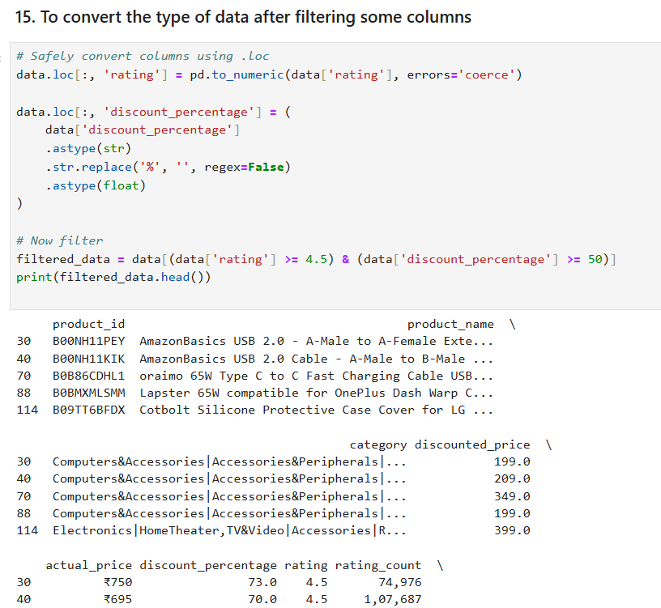

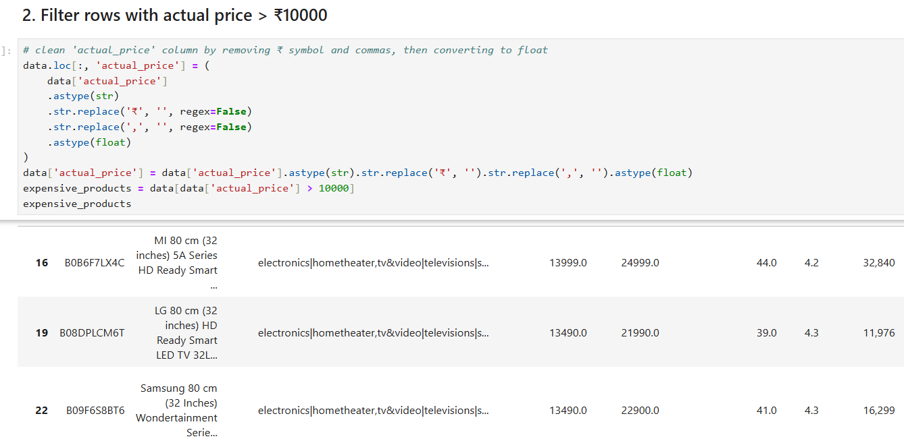

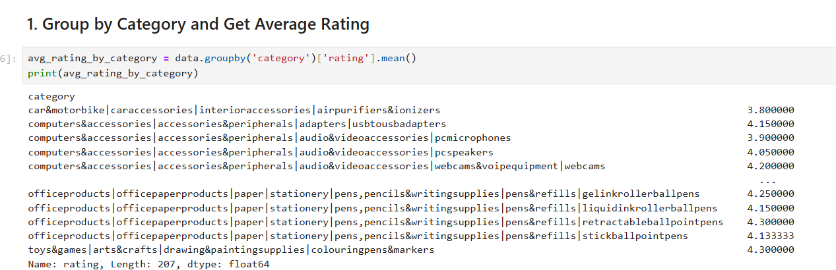

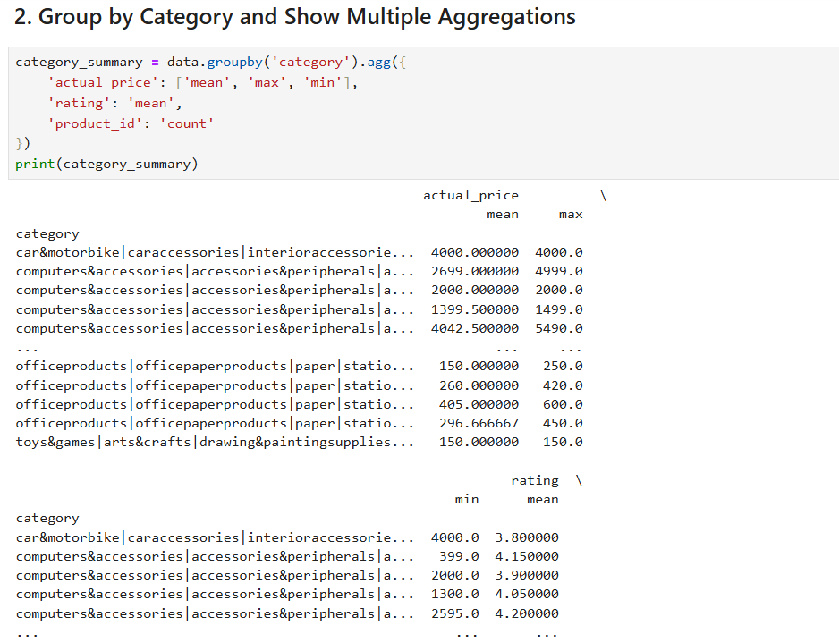

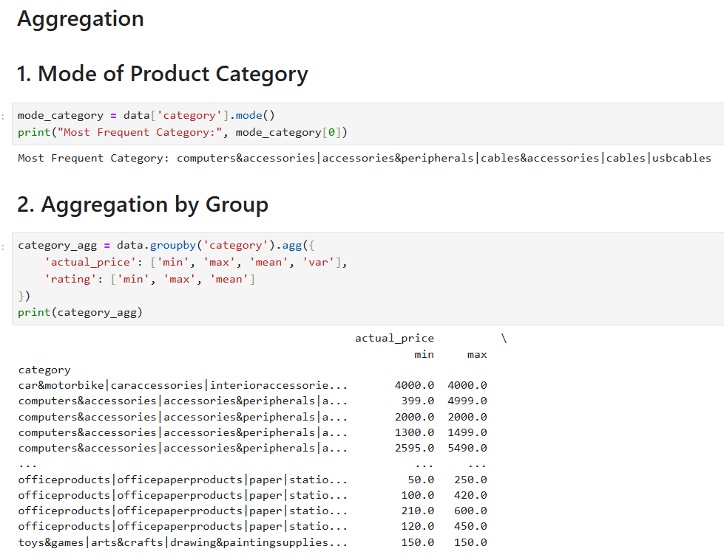

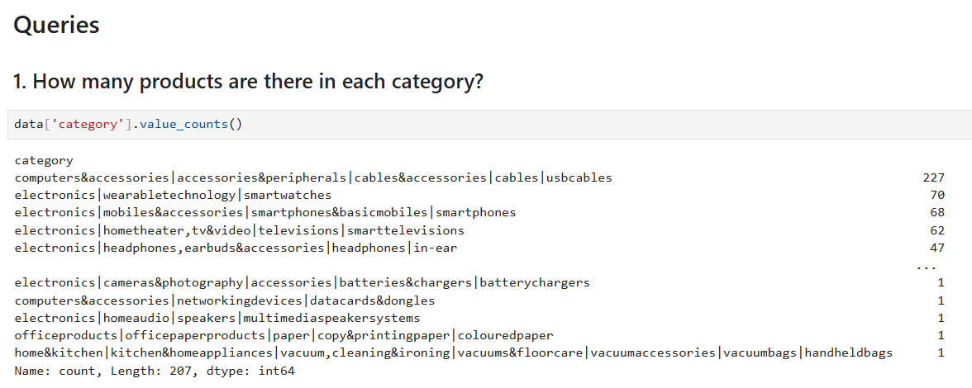

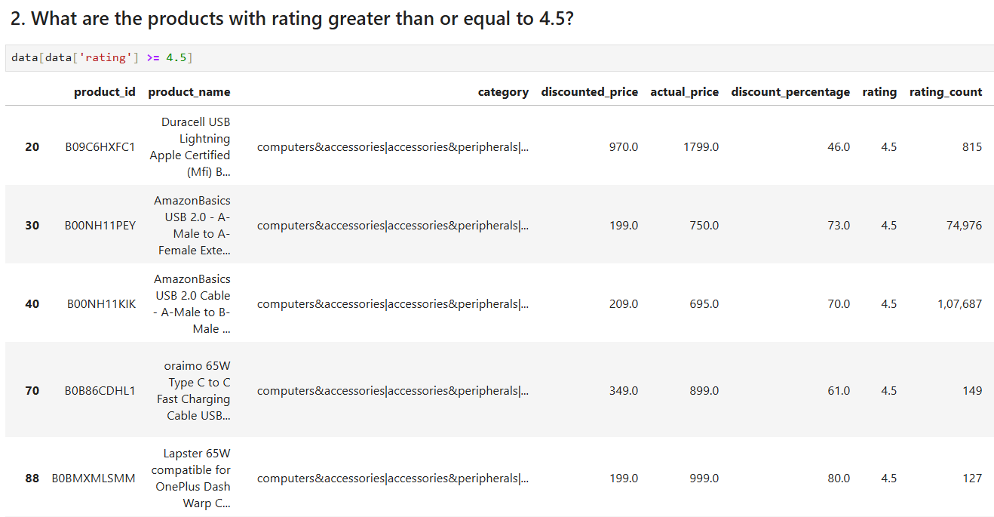

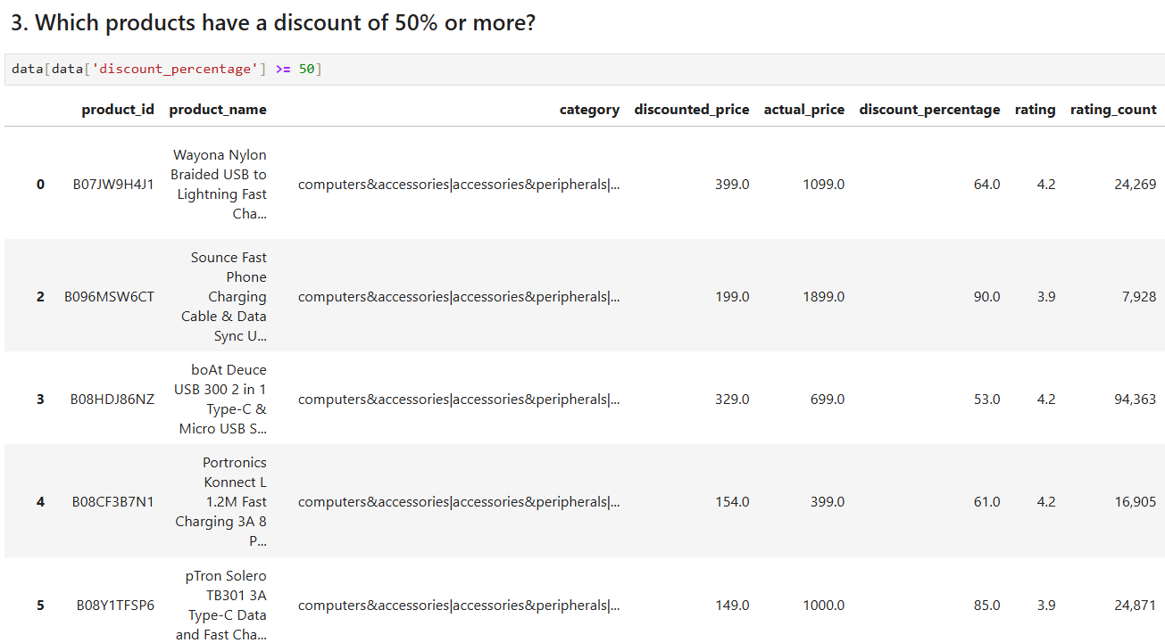

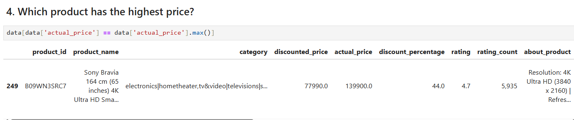

**7. Screen Shots**

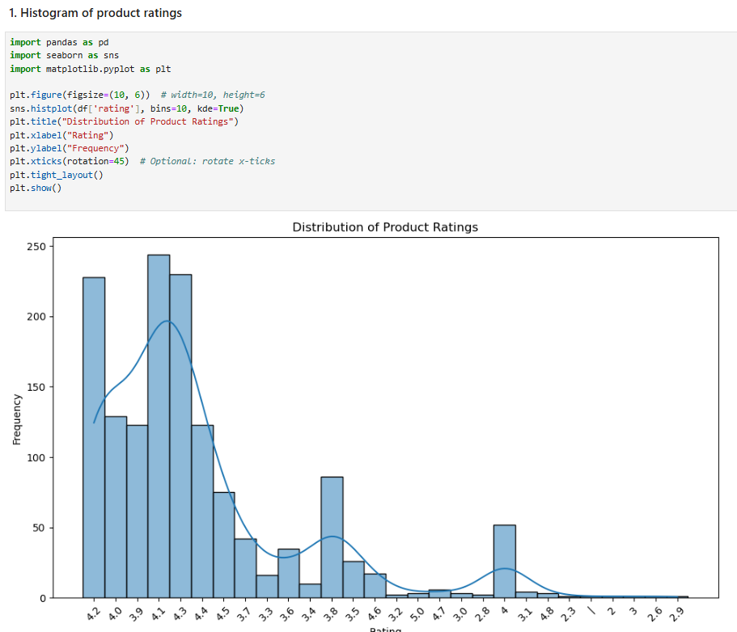

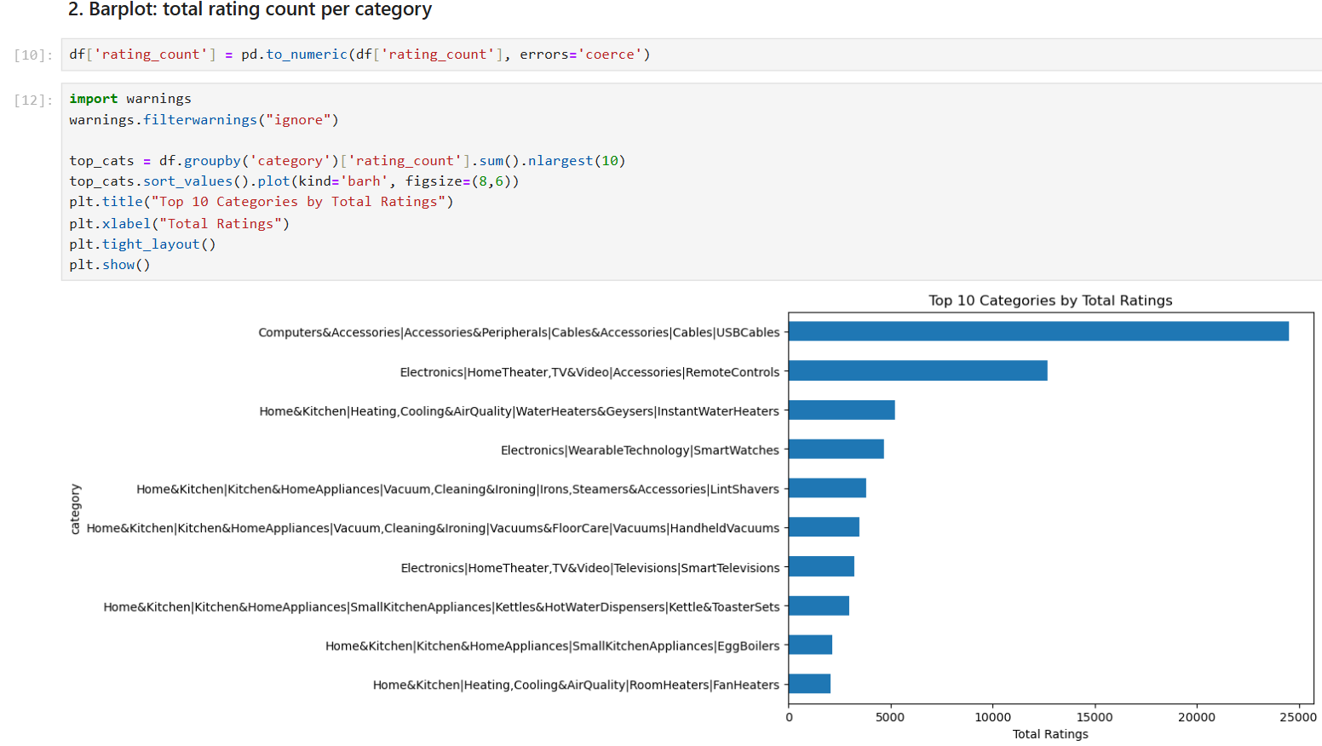

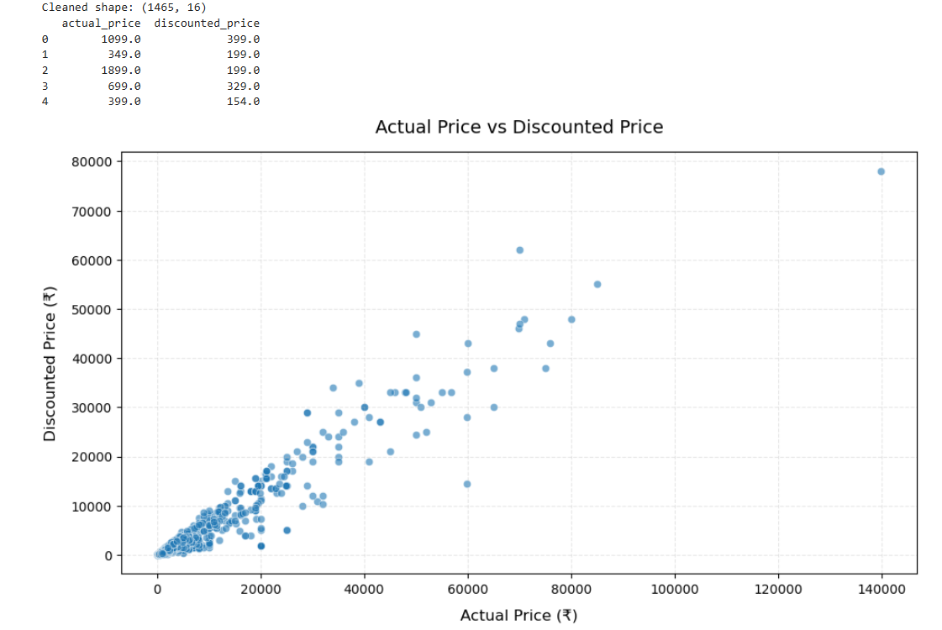

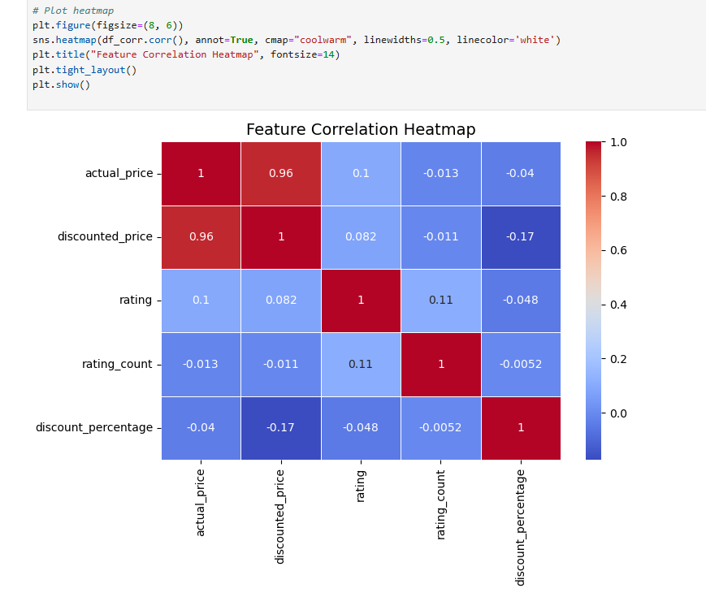

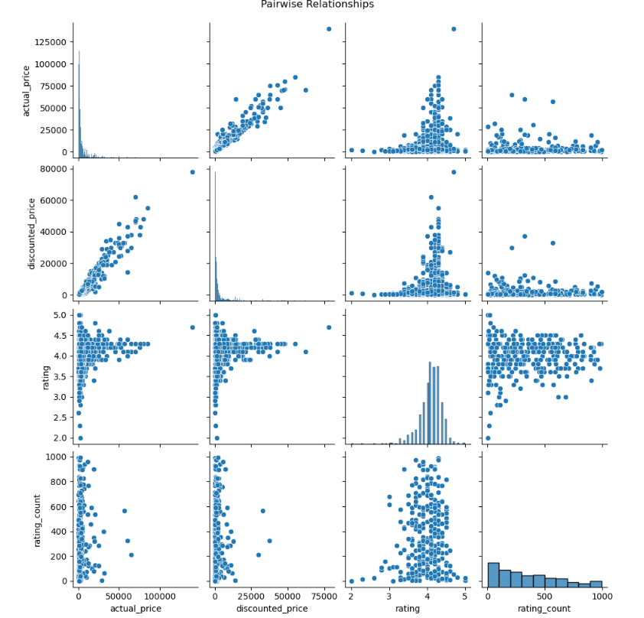

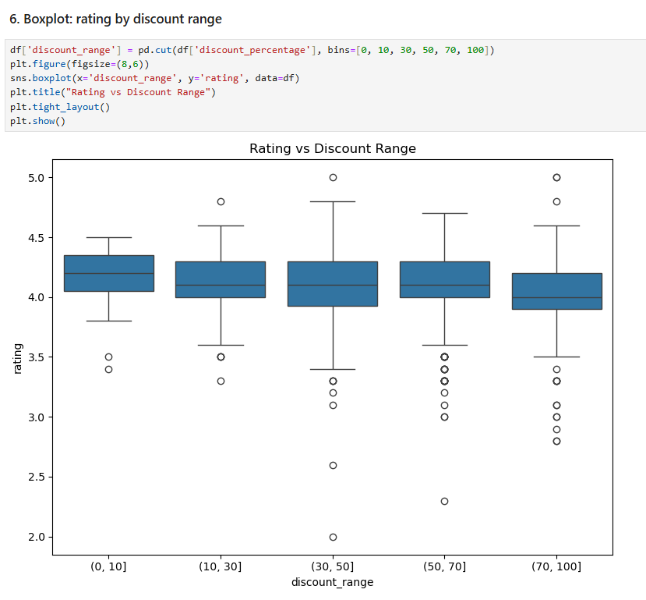

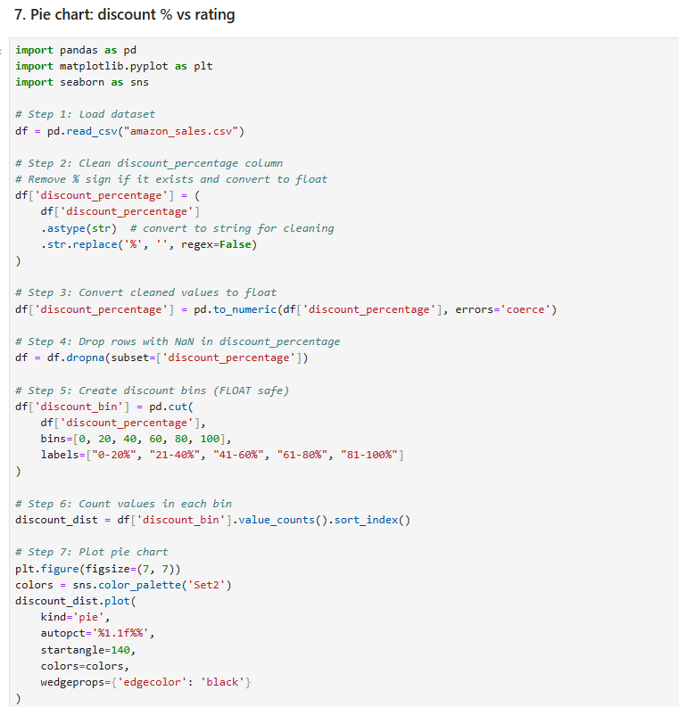

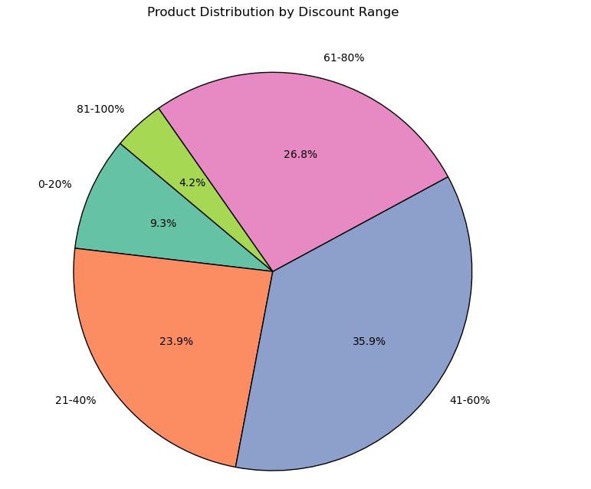

**8. Advantages**

The implementation of a data-driven analytical framework on Amazon sales data delivers multifaceted advantages spanning operational, strategic, and technological dimensions. By harnessing advanced data science methodologies and automation-enabled workflows, this project catalyzes enterprise-wide transformation in decision-making, customer engagement, and revenue optimization.

**8.1. Enhanced Decision-Making**

The project empowers stakeholders with **evidence-backed decision support systems** by translating raw sales data into actionable insights. Through real-time **Key Performance Indicator (KPI) monitoring**, **trend extrapolation**, and **anomaly detection**, it enables:

* Data-informed strategic planning
* Proactive response to market dynamics
* Precision targeting in marketing and procurement initiatives

This leads to a shift from **intuition-based** to **quantified, data-backed decisions**, aligning business operations with measurable objectives.

**8.2. Operational Efficiency**

Through **automation of repetitive tasks**—such as data cleansing, transformation, and visualization—the system significantly reduces the time and effort required for routine analysis. It supports:

* **Automated inventory demand forecasting** using temporal patterns
* **Rule-based alerting mechanisms** for supply-chain bottlenecks
* **Dynamic reordering and stock level monitoring**

This enhances supply chain agility and streamlines operations by minimizing manual intervention and **latency in data workflows**.

**8.3. Customer Segmentation and Behavioral Profiling**

The analysis enables **granular segmentation** of customer cohorts based on transactional behavior, frequency, order value, and product affinity. Leveraging this, businesses can implement:

* **Personalized recommendation engines**
* **Targeted loyalty programs** based on Recency, Frequency, Monetary (RFM) metrics
* **Churn prediction models** for retention campaigns

This drives **customer lifetime value (CLV) maximization** and fosters long-term brand loyalty through **hyper-personalization**.

**8.4. Predictive Trend and Seasonal Analysis**

Advanced **time-series decomposition** and **moving average smoothing techniques** are employed to identify:

* **Top-performing SKUs**
* **Seasonal sales peaks**
* **Promotional impact assessment**

These insights allow for **preemptive stock allocation**, **just-in-time (JIT)** inventory models, and **calendar-aware marketing campaigns**, ensuring synchronized demand-supply alignment.

**8.5. Profitability Optimization**

The platform enables **profit margin analysis** by identifying:

* Underperforming SKUs that require phasing out
* High-margin product clusters with high conversion rates
* Price sensitivity through **elasticity models** and discount effectiveness tracking

This supports **data-driven pricing strategies**, **portfolio optimization**, and **strategic bundling**, maximizing revenue per transaction.

**8.6. Time Efficiency and Workforce Productivity**

By automating the entire **ETL (Extract, Transform, Load)** process and dashboard generation, the system drastically reduces the **Time-to-Insight (TTI)**:

* Speeds up **report generation cycles**
* Minimizes dependency on manual spreadsheet operations
* Enables **on-demand insights** via interactive dashboards

This allows data analysts and decision-makers to focus on **high-value strategic tasks** rather than operational reporting.

**8.7. Scalability and Future-Readiness**

Designed with **modular architecture** and **API extensibility**, the system is capable of scaling to accommodate:

* **Real-time data streaming** via Apache Kafka or Spark
* **Integration with cloud-based data lakes** (e.g., AWS S3, GCP BigQuery)
* **Deployment of predictive models** and real-time recommendation engines

This ensures long-term viability and adaptability to **evolving business intelligence ecosystems**.

**8.8. Competitive Advantage**

Through continuous monitoring and adaptive analytics, the platform acts as a **strategic intelligence layer** that:

* Enhances **market responsiveness**
* Accelerates **go-to-market** strategy development
* Facilitates **benchmarking against competitors**

This agility empowers the business to **capitalize on emerging consumer trends**, rapidly iterate on product offerings, and maintain **a sustainable edge in a dynamic marketplace**.

In summary, the analytical system transforms Amazon sales data into a **strategic asset**, aligning data science with business objectives to unlock competitive, operational, and financial excellence at scale.

**9. Conclusion**

This analytical framework affirms the transformative potential of data science methodologies in the rapidly evolving landscape of digital commerce. Through the comprehensive exploration of Amazon sales data, this project demonstrates how structured data pipelines, exploratory data analysis (EDA), and statistical visualization can be effectively harnessed to generate actionable business intelligence (BI) that drives measurable outcomes across operational and strategic domains.

The systematic decomposition of high-dimensional sales records has yielded critical insights into consumer behavior, temporal sales dynamics, regional purchasing patterns, and product category performance. This intelligence enables evidence-based refinement of promotional strategies, targeted inventory allocation, and regional sales forecasting, ensuring both agility and precision in business decision-making.

By surfacing metrics such as average order value (AOV), basket size, SKU-level contribution, and seasonal variance, the project delivers deep insights that inform:

* Dynamic pricing strategies aligned with market responsiveness
* Cross-selling and upselling algorithms to enhance revenue per customer
* Geo-segmented marketing personalization for increased engagement
* Customer Lifetime Value (CLV) modeling for strategic retention planning

Furthermore, the deployment of automated data wrangling, outlier detection, and pattern recognition techniques ensures minimal data redundancy, increased signal-to-noise ratio, and improved analytic accuracy. The scalable pipeline architecture supports integration with business intelligence tools, real-time dashboards, and self-service analytics environments, making the insights highly accessible to cross-functional teams including sales, marketing, finance, and logistics.

The project establishes a foundation for further sophistication by enabling predictive modeling, clustering-based segmentation, and multivariate regression analysis. Future extensions could include:

* Machine learning integration using supervised and unsupervised algorithms for advanced trend forecasting, churn prediction, and demand modeling.
* Time-series forecasting frameworks (e.g., ARIMA, Prophet, LSTM) for high-resolution sales prediction and anomaly detection.
* API-driven ETL pipelines that allow continuous data ingestion from live commerce systems, ensuring near-real-time analytics.
* Cloud deployment on platforms such as AWS (S3, Redshift, SageMaker), Google Cloud (BigQuery, Vertex AI), or Azure (Synapse, ML Studio) for scalability, fault tolerance, and centralized data governance.

In essence, this project not only extracts strategic value from historical sales data but also establishes a blueprint for data-driven transformation in e-commerce. It promotes operational excellence, customer-centric optimization, and competitive agility in an increasingly data-saturated marketplace.

**10. References**

* <https://pandas.pydata.org/>
* <https://numpy.org/>
* <https://seaborn.pydata.org/>
* <https://matplotlib.org/>
* <https://scikit-learn.org/>
* <https://plotly.com/python/>
* <https://www.kaggle.com/>
* <https://www.geeksforgeeks.org/python-pandas-tutorial/>
* <https://realpython.com/pandas-python-explore-dataset/>
* <https://towardsdatascience.com/>